**Software Requirements Specification**

1. **Introduction**
   1. **Purpose and Scope:**

The purpose of the Inventory Management System is to allow donation centers to track donations coming in, some donor information and history, amount of a donation, location of a donation, and some descriptive elements of a donation. This software will provide inventory management on an enterprise level, allowing organizations of all sizes to link with each other and with warehouse facilities to manage incoming donations and distribution to needy families and individuals. It is scalable to support operations of smaller food distribution charities that would prefer to remain independent of large scale inter-organization consortiums.

* 1. **Glossary**

Organization: The location where the inventory items are.

Donor: The person or organization that is donating food items.

Category: More information about the item. Used to sort and search.

1. **Overall Description**
   1. **Problem Description:**

Most major metropolitan areas have an array of food banks serving the same mission but scattered throughout the city. Many of these sites work autonomously or within affiliated groups of varied sizes. We are proposing Fuel, a scalable application solution offering automation and inter-communication of services between non-profit donation and warehouse sites. With our application, we aim to facilitate non-profit organizations to further their goals in serving the community.

* 1. **Context of Use:**

Fuel will be used as the link between various donation sites so that they can all view what each other have in stock and request more of an item if they are running low.

* 1. **Users:**

Fuel will be primarily used by employees and management of the organization receiving donations.

* 1. **System Goals:**

Fuel will be a success when donations, donors, and organizations are able to be added and when donations are able to be deleted and modified, signifying that they have either expired, been picked up, or moved to another location.

1. **Specific Requirements**
   1. **User Stories and**

The User Stories are interspersed with the BDD Scripts that pertain to them for better clarity.

* 1. **BDD Scripts:**

The BDD Scripts and User Stories depart from the stratified outline in a single atomic section.

**INVENTORY**

**3.1.1** - As a staff member, I want to click a button on the homepage

so that I can navigate directly to the Inventory page.

Background: inventories in database

Given the following inventories exist:

| itemnum | orgnum | quantity | expires | category |

| 1234 | UNO | 12 | 2019/August/19 | Can |

Scenario: connect to 'Inventories' page

Given I am on the Fuel Donation Management System home page

When I follow "Inventory"

Then I should be on the Listing Inventories page

**3.1.2** - As a staff member, I want to add, edit, delete, and show information in Inventory page

so that I can create and modify the inventory.

Scenario: add a new inventory to page

Given I am on the Listing Inventories page

When I follow "Add to Inventory"

And I fill in "ItemNum" with "1345"

And I fill in "Organization" with "PKI"

And I fill in "Quantity" with "2100"

And I press "Save"

Then I should see "1345"

Scenario: Edit the existing inventories to page

Given I am on the Fuel Donation Management System home page

When I follow "Inventory"

And I follow "Edit"

And I fill in "Organization" with "UNOmaha"

And I press "Save"

Then I should see "UNOmaha"

Scenario: Delete an existing inventory to page

Given I am on the Fuel Donation Management System home page

When I follow "Inventory"

And I delete the Inventory with the number of "1234"

And a confirmation box saying "Are you sure?" should pop up

And I want to click "Ok"

Then I should not see "1234"

Scenario: Show an existing record of inventory

Given I am on the Fuel Donation Management System home page

When I follow "Inventory"

And I show the Inventory with the number of "1234"

Then I should see "1234"

**3.1.3** - As a staff member, I want to open a form by checking the 'Browse/Update' box on the Inventory page

so that I can quickly browse items in the inventory.

Scenario:

Given I am on the Inventory page

When I check the 'Browse/Update' box

Then I expect the inventory browse/update form to be displayed

And I can see several entries from the inventory as rows and columns

When I enter valid data in any of the columns of the blank row at the bottom

And I click the 'Search' button

Then I expect to see the inventory entries that match the search data from the columns.

**3.1.4** - As a staff member, I want to filter items by one or more categories

so that I can view the information most relevant to me.

Scenario:

Given I am on the Inventory browse/update page

And there are items of multiple categories in the database

When I select 'canned’' from the category pulldown list and click on the 'Filter' button

Then I expect to see only ‘canned’ items in the inventory list.

Scenario:

Given I am on the Inventory browse/update page

And there are one or more categories selected and I click on 'Clear All'

Then I expect to see all current items unfiltered in the inventory list.

And all entries to the blank row at the bottom are cleared.

**3.1.5** - As a staff member, I want to filter items by expiration date

so that I can discard items that are too old to distribute.

Scenario:

Given I am on the Inventory browse/update page

When I click on the 'Expiration date' column header

Then I expect to see inventory items sorted by expiration date

And expired items are highlighted in red.

**3.1.6** - As a staff member, I want to select a category for a new or existing item

so that item can be filtered by category in inventory.

Scenario:

Given I am on the Inventory add page

And the item name, quantity, and expiration date are populated with valid data

When I select ‘canned’ from the category list

And I click on 'Save'

Then I expect to see ‘canned’ on the information page for that item.

Scenario:

Given I am on the Inventory browse/update page

And the item name, quantity, and expiration date are populated with valid data

When I select ‘canned’ from the category list

And I click on 'Save'

Then I expect to see ‘canned’ on the information page for that item.

**INVENTORY POPUP**

**3.1.7** - As a staff member, I want to see an information dialog popup when I add or update inventory

so that I know my action was successful or not.

Scenario:

Given I am on the Inventory add page

And the item name, quantity, and expiration date are populated with valid data

And the item name exists in the database

When I click on 'Save'

Then I expect to see a popup with the 'Item added!' message

Scenario:

Given I am on the Inventory add page

And the item name, quantity, and expiration date are populated with valid data

And the item name does not exist in the database

When I click on 'Save'

Then I expect to see a popup with the 'Select Category!' message.

When I select a category for the item

And I click on ‘Save’

Then I expect to see a popup with the 'Item updated!' message

Scenario:

Given I am on the Inventory browse/update page

And the item name, quantity, and expiration date are populated with valid data after an edit

And the item name exists in the database

When I click on 'Save'

Then I expect to see a popup with the 'Item updated!' message

**ORGANIZATIONS**

Feature: testing Organization page

**3.1.8** - As a staff member, I want to click a button on the homepage, add new organization

so that I can navigate directly to the Organizations page.

Background: an empty database from beginning and store organization name when added

Given the following organizations exist:

| org_name | address | phone | contact_id |

| UNO | 6700 Dodge St | 402-654-9874 | Huong |

Scenario: connect to 'Current Organizations' page

Given I am on the Fuel Donation Management System home page

When I follow "Current Organizations"

Then I should be on the Current Organizations page

**3.1.9** - As a staff member, I want to add, edit, delete, and show information in organiztions page

so that I can create and modify the organizations.

Scenario: add a new organization to page

Given I am on the Current Organizations page

When I follow "New Organization"

And I fill in "Organization" with "UNO"

And I fill in "Address" with "6700 Dodge Street"

And I fill in "Phone" with "402-554-2100"

And I fill in "Contact" with "Huong"

And I press "Create Organization"

Then I should see "UNO"

Scenario: Edit an existing organization to page

Given I am on the Fuel Donation Management System home page

When I follow "Current Organizations"

And I follow "Edit"

And I fill in "Organization" with "UNOmaha"

And I press "Update Organization"

Then I should see "UNOmaha"

Scenario: Delete an existing organization to page

Given I am on the Fuel Donation Management System home page

When I follow "Current Organizations"

And I delete the Organization with the Name of "UNO"

And a confirmation box saying "Are you sure you want to delete this organization?" should pop up

And I want to click "Ok"

Then I should not see "UNO"

Scenario: Show an existing record of organization

Given I am on the Fuel Donation Management System home page

When I follow "Current Organizations"

And I show the Organization with the Name of "UNO"

Then I should see "UNO"

**ORGANIZATIONS POPUP**

**3.1.10** - As a staff member, I want to see an information dialog popup when I add or update an organization

so that I know if my action was successful or not.

Scenario:

Given I am on the Organizations add page

And the organization name, address, phone, and contact are populated with valid data

When I click on 'Save'

Then I expect to see a popup with the 'Organization added!' message

Scenario:

Given I am on the Organizations browse/update page

And the organization name, address, phone, and contact are populated with valid data after an edit

When I click on 'Save'

Then I expect to see a popup with the 'Organization updated!' message

**DONORS**

Feature: Checking CRUD functions for Donors page

**3.1.11** - As a staff member

So that I can update, delete, and create a donor

Background: donor in database

Given the following donors exist:

| donorName | phoneNum |

| XYZ Corp | 402-654-9874 |

| Test Inc. | 402-111-1111 |

**3.1.12** - As a staff member, I want to click a button on the homepage

so that I can navigate directly to the Donors page.

Scenario: Access donors page from home page

Given I am on the Fuel Donation Management System home page

When I follow "Current Donors"

Then I should be on the Current Donors page

**3.1.13** - As a staff member, I want to open a form from the Donors page

so that I can add new donors as needed.

Scenario: Access to New Donor page

Given I am on the Current Donors page

When I follow "New Donor"

And I fill in "Name" with "Mike Crook"

And I fill in "Phone" with "402-554-9067"

And I press "Create Donor"

Then I should see "Mike Crook"

Scenario: Access edit donors form from donors page

Given I am on the donors page

When I follow "XYZ Corp"

Then I follow "Edit"

And I fill in "Phone" with "555-987-1234"

And I press "Update Donor"

And I follow "XYZ Corp"

Then I should see "Phone: 555-987-1234"

**DONORS POPUP**

**3.1.14** - As a staff member, I want to see an information dialog popup when I add or edit a donor

so that I know my action was successful or not.

Scenario:

Given I am on the Donors add page

And the donor name, address, phone, and contact are populated with valid data

When I click on 'Save'

Then I expect to see a popup with the Donor added!' message

Scenario:

Given I am on the Donors browse/update page

And the donor name, address, phone, and contact are populated with valid data after an edit

When I click on 'Save'

Then I expect to see a popup with the 'Donor updated!' message

**EXTENDED FUNCTIONALITY**

**3.1.15** - As a staff member, I want to select a dietary restriction for a new or existing item

so that item can be filtered by dietary restriction in inventory.

Scenario:

Given I am on the edit item page

And the item name, quantity, and expiration date are populated with valid data

When I select 'Gluten-free' in the dietary restriction list

And click on 'Save'

Then I expect to see 'Gluten-free' on the information page for that item.

**3.1.16** - As an administrator, I want to be alerted when the quantity of an item is below a set threshold

so that I can solicit new donations.

Scenario:

Given I am on the administrator settings page

When I click on 'New Alert'

Then I expect to be directed to the new alert form.

**3.1.17** - As an administrator, I want to see donors sorted by quantity of contributions

so that I can solicit new donations or send thanks.

Scenario:

Given I am on the Donors page

When I check the 'Browse/Update' box

Then I expect to see the organizations browse/update form displayed

When I click on the ‘Contact’ column

Then I expect to see the donors sorted by total quantity of donations, descending.

* 1. **Lo-fi Prototypes:**

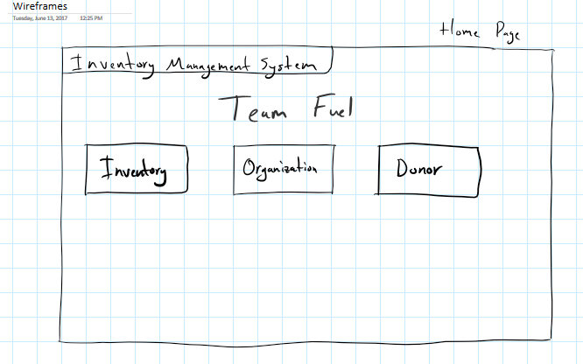

The User Stories requested a homepage that offered quick “one button” access to the core functions of the Fuel Inventory Management System.

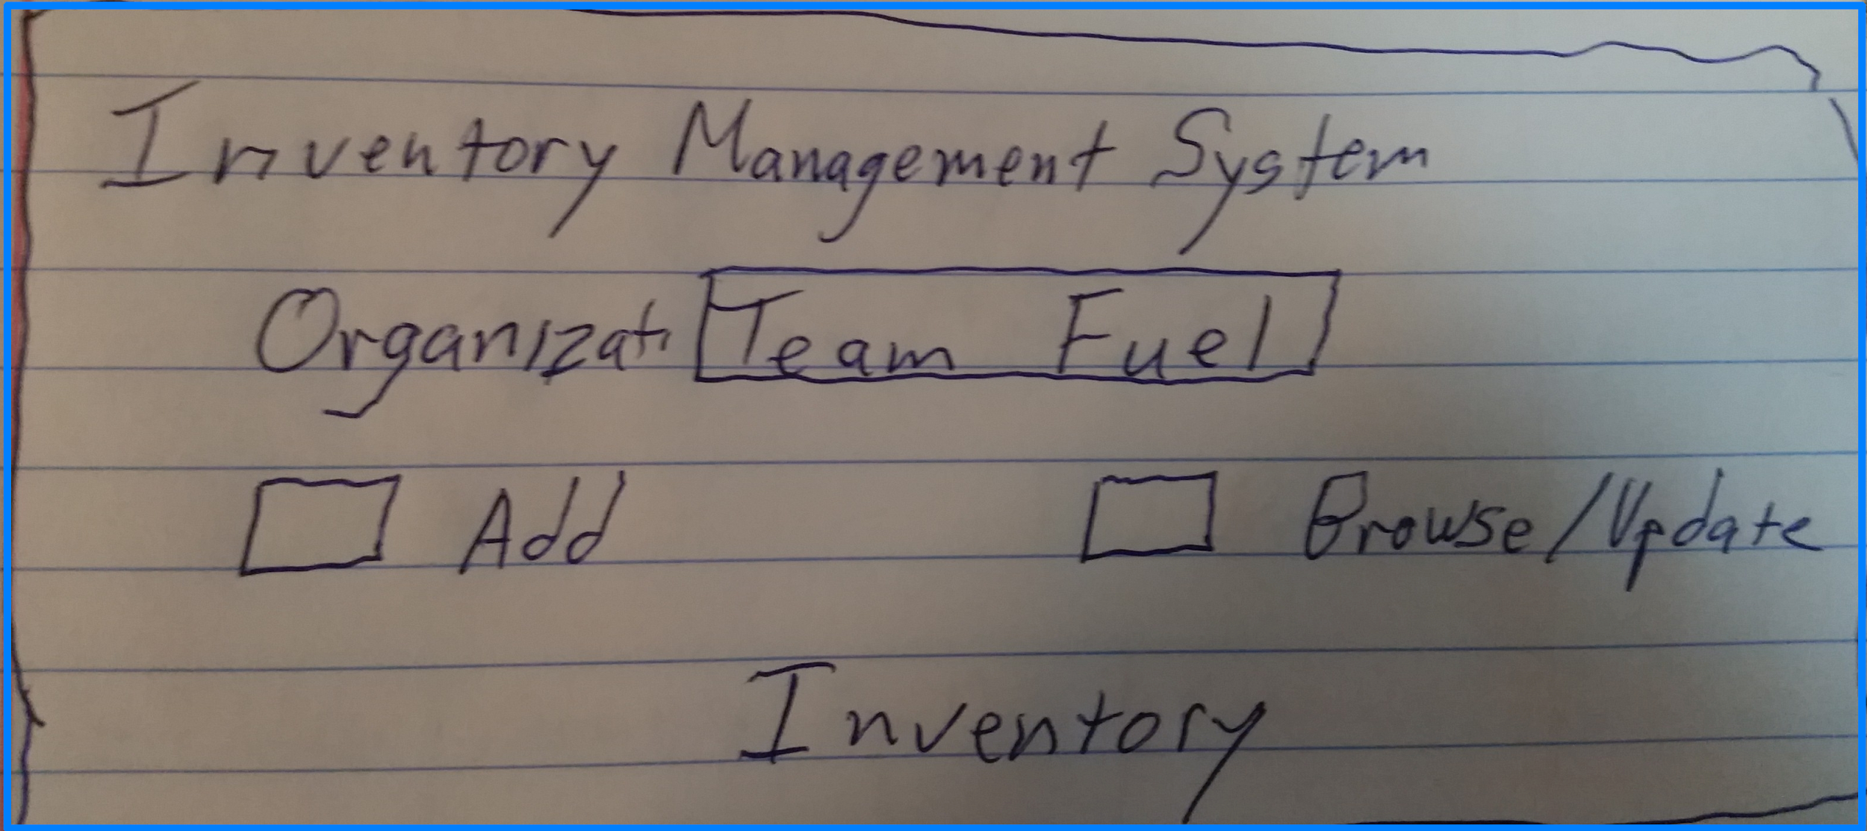

The Inventory Page provides a choice of form to be displayed, whether you’d like to Add items to the inventory or Browse/Update the inventory. When a user is on the Inventory pages, the organization is always displayed near the top of the page. This can be changed at any time, but a user needs to be aware of the orientation of the FUEL Inventory Management System with respect to the other organizations since, for instance, an add will be logged to the organization whose name is in that box.

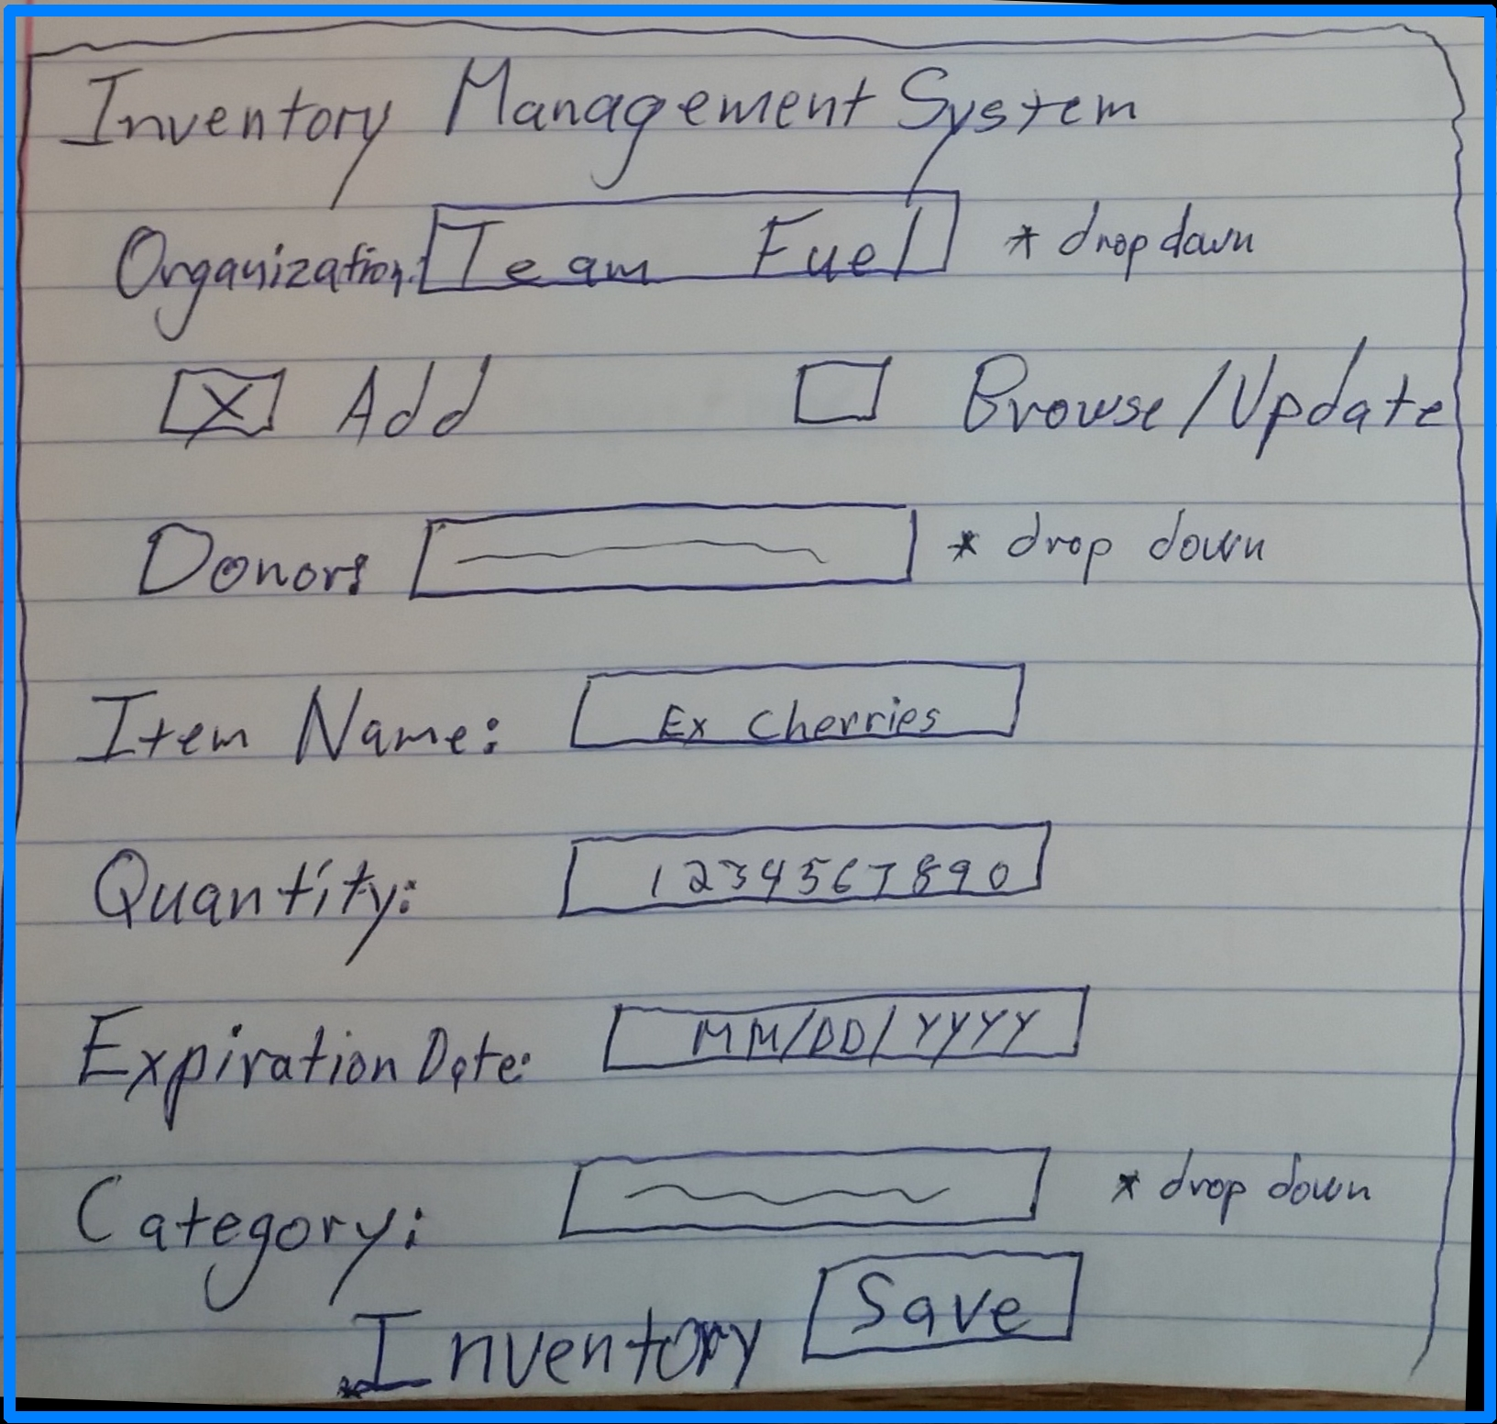

The Inventory Add form is intended to retain the settings for Donor and Organization until they are changed. This is to streamline the process of adding a large donation of food items from a single donor. This is the common flow of food donations into the food bank. The item name is the first field to be populated by a staff member on this form and attempts will be made to find the item in the Item table while a user is in the process of filling out the form. If successful then the category field should be pre-filled, otherwise the form will display an error if the category has not been set before the ‘Save’ button is pressed.

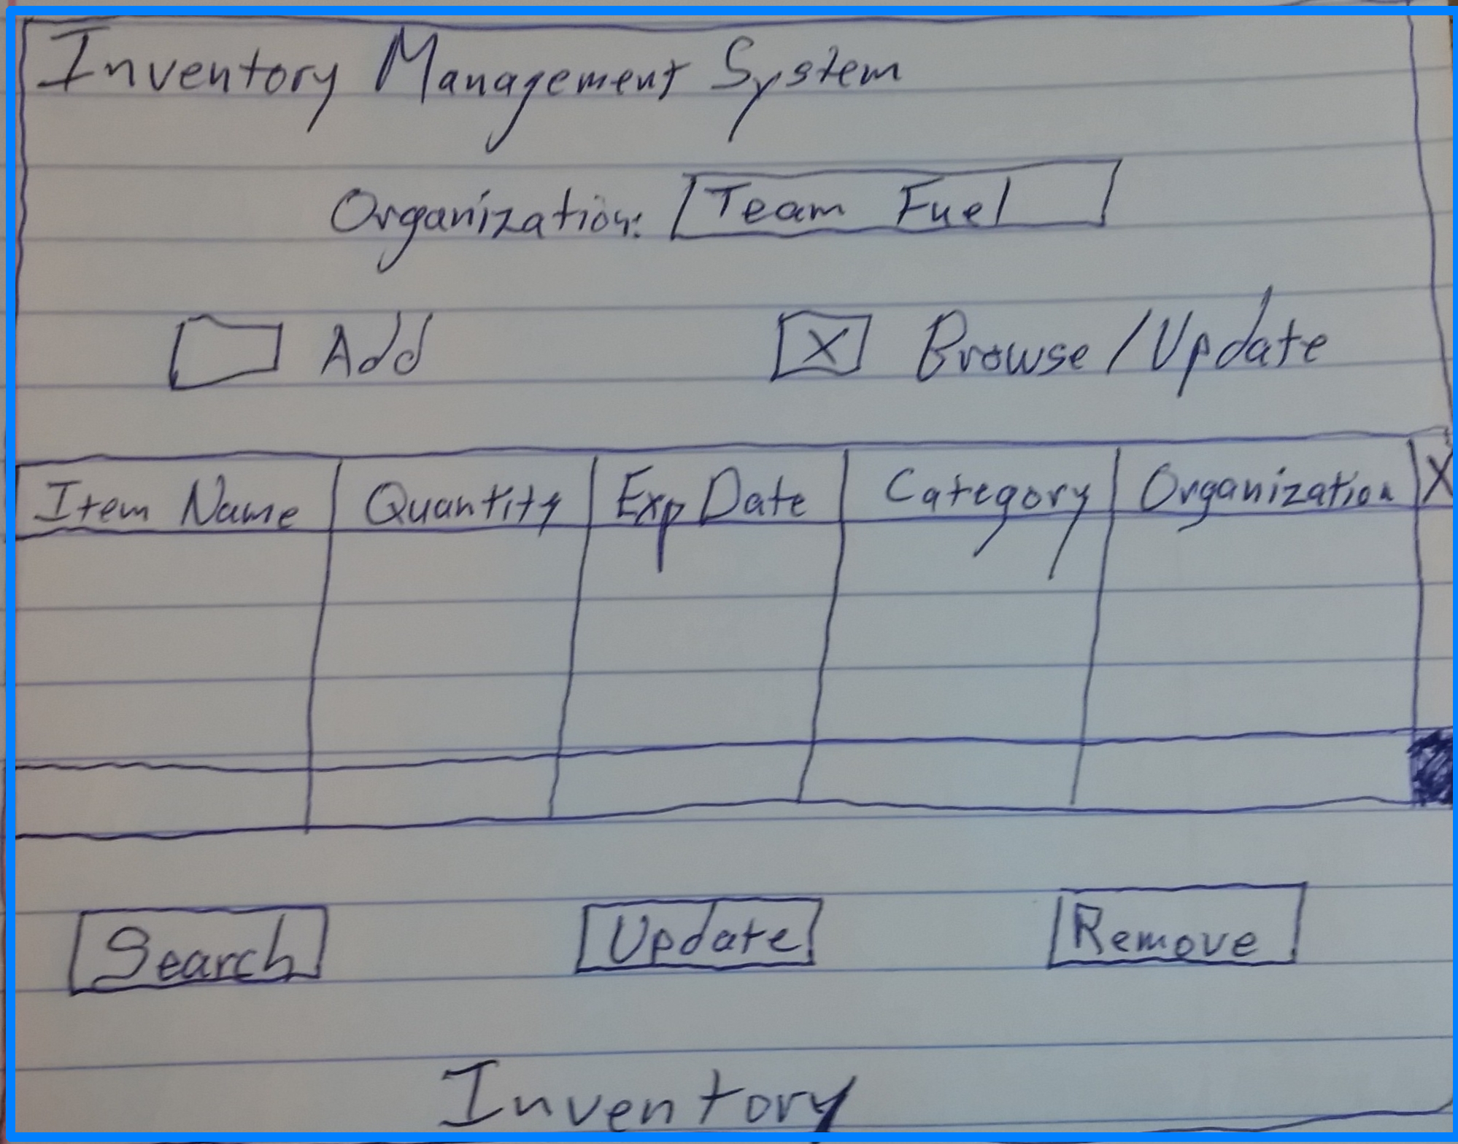

The browse/update facility from the Inventory page allows sorting by clicking on column headings. There is a blank row at the bottom of the form where a user can enter relevant search strings to get a list of items that match the search characteristics. The blank row is also used to update one of the displayed rows. The user checks one of the boxes at the end of the rows to designate the entry to be updated. The data from the selected row will display in the bottom and the user can then edit that data and press ‘Update’ when finished.

Checking the box at the end of the row and then pressing the ‘Remove’ button will remove the entry from the database.

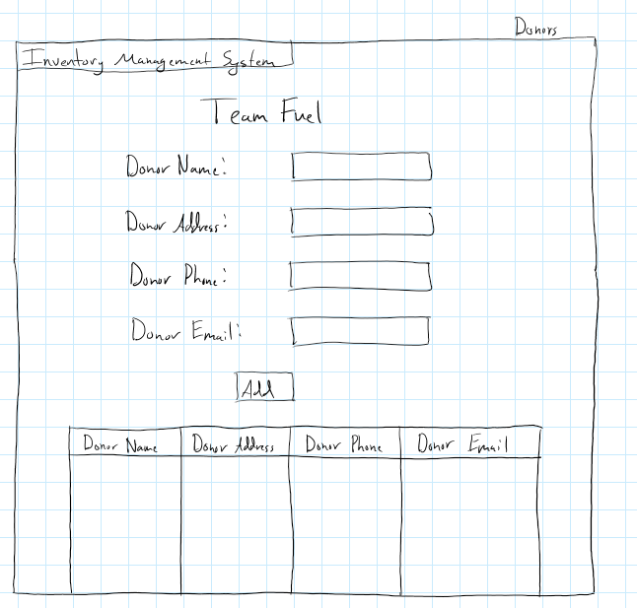

The Donors page is a combination of the Add and the Browse/Update functionality that the Inventory page has. This example appears to be missing some buttons though.

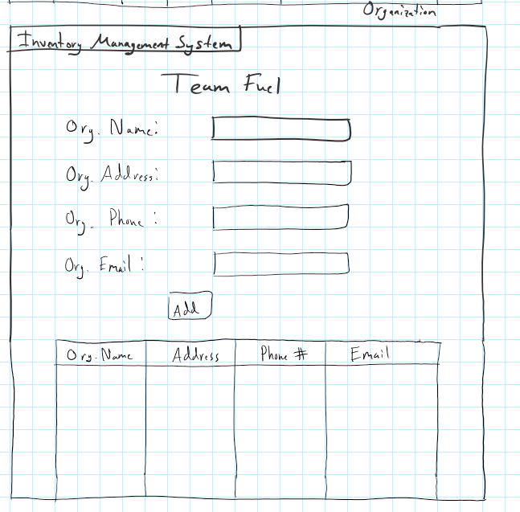

The Organizations page is a combination of the Add and the Browse/Update functionality that the Inventory page has. This example appears to be missing some buttons though.

* 1. **Object Model:**

